**Supporting Information**

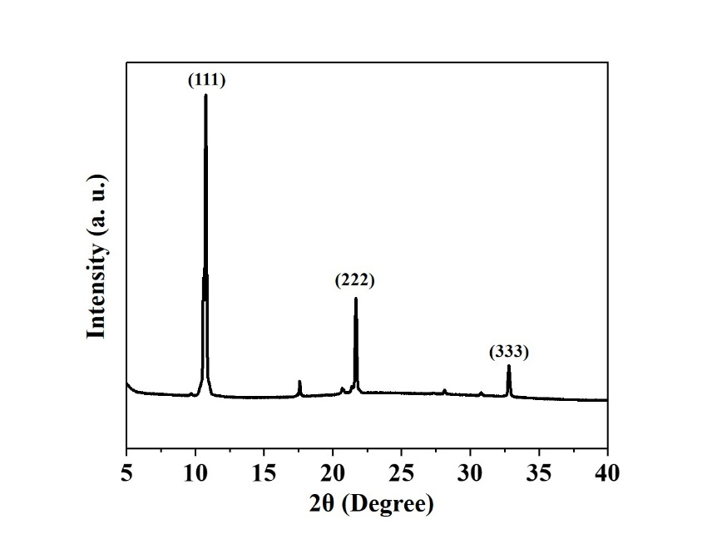

**Fig. S1** XRD patternof another C60 crystal.

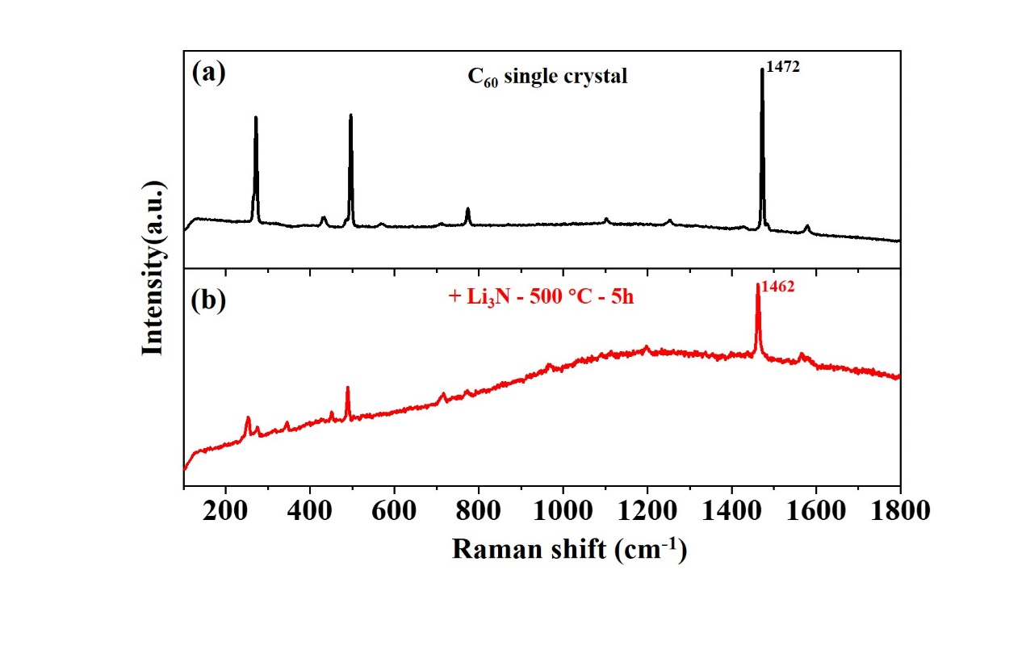

**Fig. S2** Raman spectra collected with a laser wavelength of 785 nm (a) before and (b) after annealing C60 crystals with α-Li3N at 500 °C for 5 h.

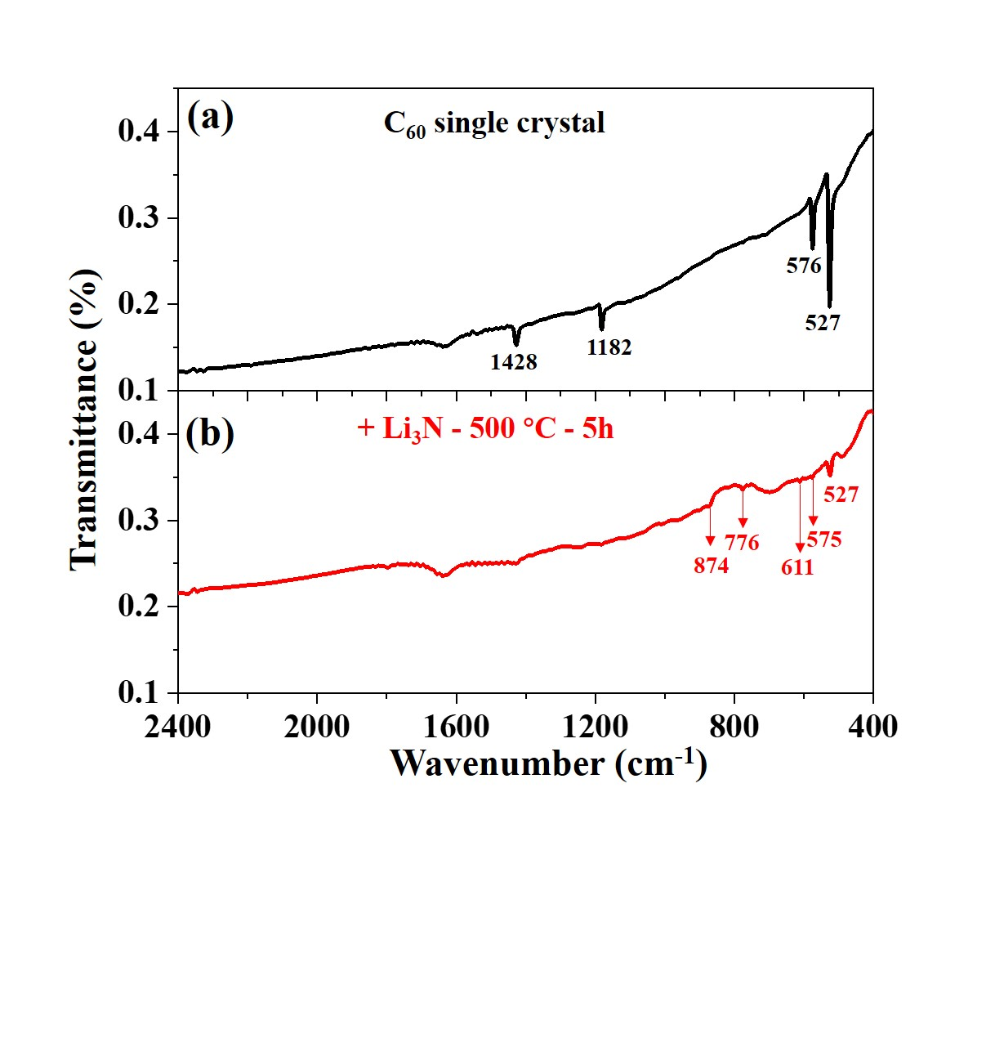

**Fig. S3** FTIR spectraof C60 crystals (a) before and (b) after annealing with α-Li3N at 500 °C for 5 h.